Informatica Introduction

# About Informatica

* Founded in 1993
* Worldwide Distributor.

# Informatica Versions

* Powermart 4.7, PowerCenter 4.7
* Powermart 5, PowerCenter 5
* Powermart 6, PowerCenter 6
* PowerCenter 7
* PowerCenter 8
* PowerCenter 9 / 9.5 / 9.6
* PowerCenter 9.5
* PowerCenter 10

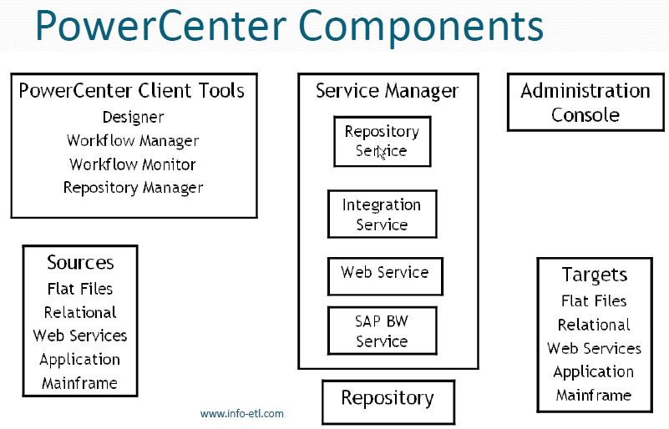

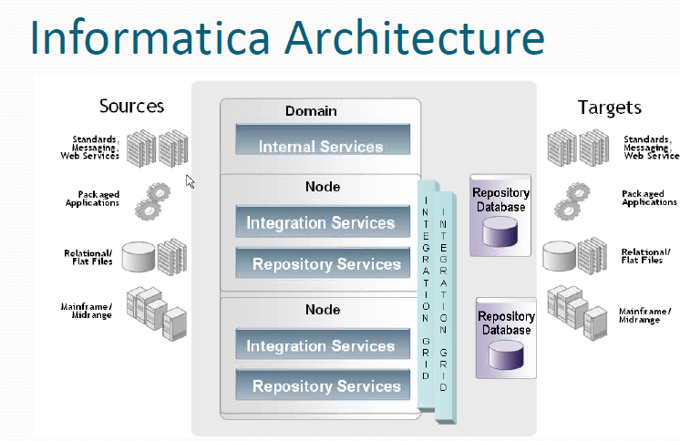

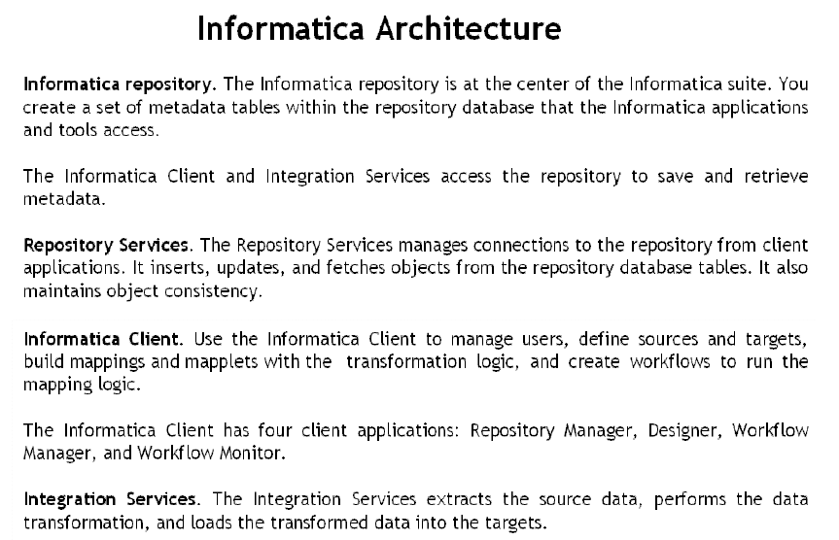

# Informatica Client Tools:

